**GST Application Unit Test Cases**

|  |  |  |  |
| --- | --- | --- | --- |
| **1. Project Information** | | | |
| Project Name | GST Application | Prepared By | Mariya Raju |
| Prepared Date | 14-09-2019 | Reviewed By |  |
| Reviewed Date |  | Execution Date |  |
|  |  | Team Name |  |

|  |  |  |  |  |  |  |
| --- | --- | --- | --- | --- | --- | --- |
| **Sl.No** | **Use Case** | **Description** | **Steps to perform** | **Use case** | **Actual Output** | **Expected Output** |
| 1 | GST insert -Success | 1. Insert required input fields like date, fee and country.  2.Total amount and GST will calculate automatically upon selecting the country from dropdown.  3.Inputed data will insert into database table upon click on submit button. | 1. Add input fields like date, fee and select country from dropdown list.  2. Click on the submit button | Positive | 1.After clicking on the submit button, alert message will populate as ‘GST inserted successfully’  2. Submitted record will display in the bottom as history records. | 1.After clicking on the submit button, alert message will populate as ‘GST inserted successfully’  2. Submitted record will display in the bottom as history records. |
| 2 | Mandatory field missing | 1.If any mandatory fields like fee or date or country is not inserted, then submit button will not be enabled. | 1. Insert fields like date and country. Submit button will be disabled until inserting the fee field. | Negative | 1.Submit button will be disabled until adding all the mandatory fields | 1.Submit button will be disabled until adding all the mandatory fields |

1. **Test case 1:**

a)Fill all the fields as below, then click on the submit button.

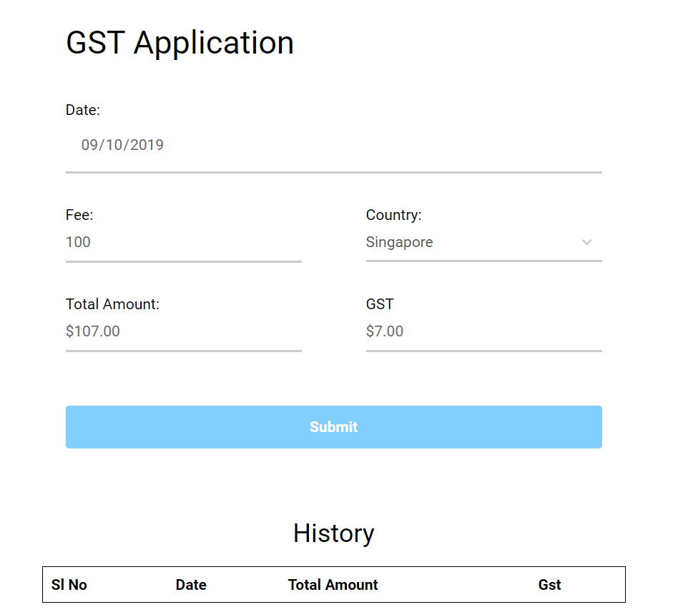

**b)**We can see a alert message as ‘GST submitted successfully’ after the submit button click.

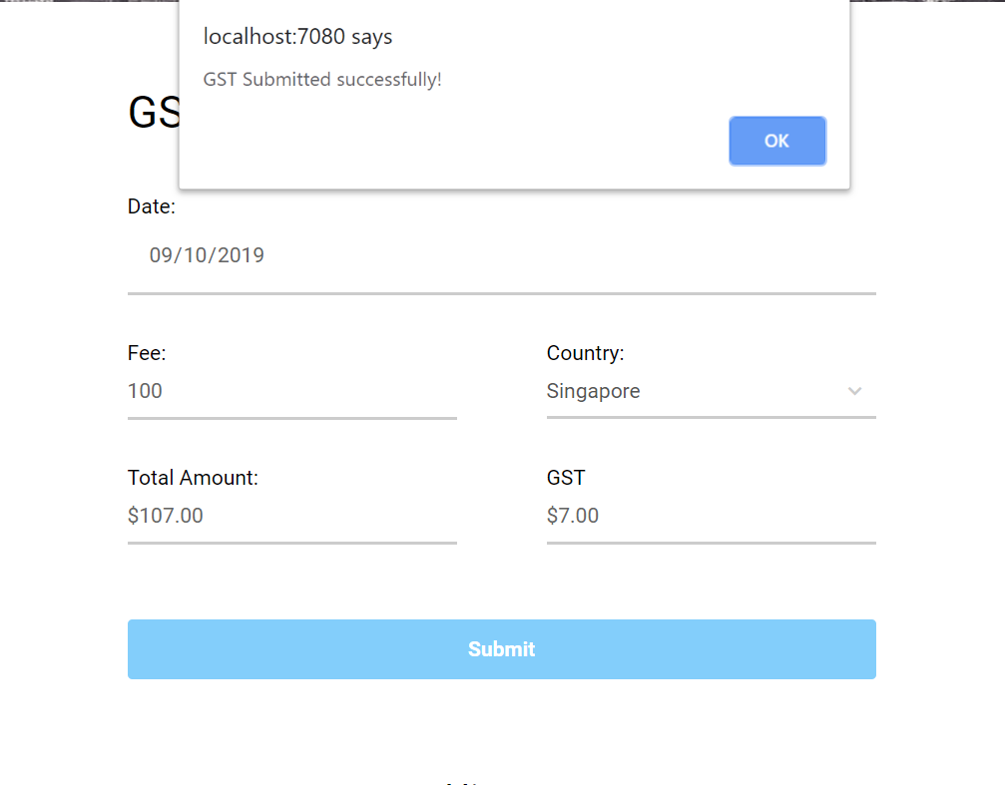

c)After click on the ‘OK’ of alert message, form will display the initial empty form with list of all the previous submission details.

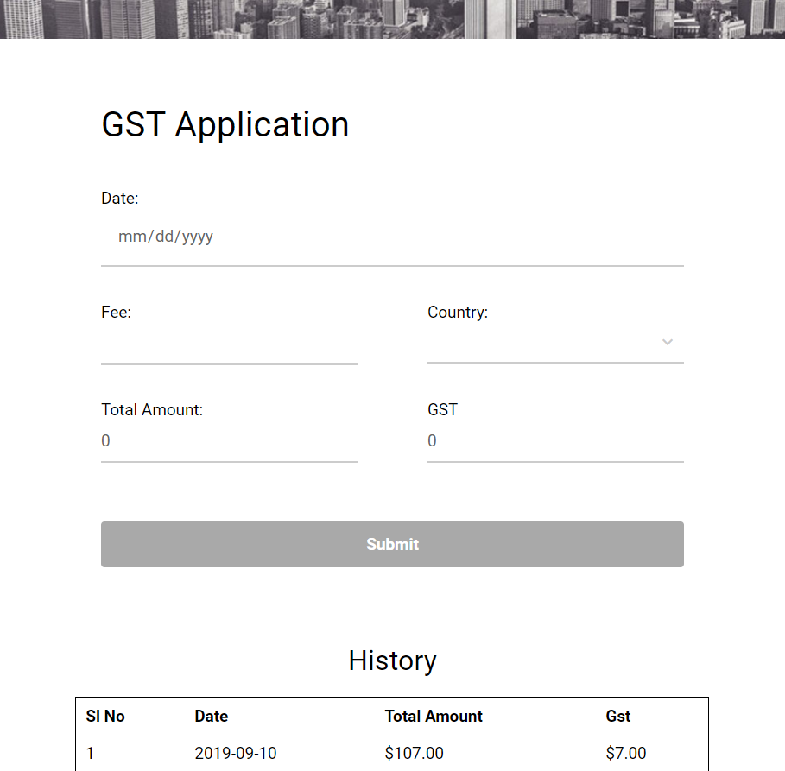

1. **Test case 2:**

Submit button will be disabled before filling the fields.

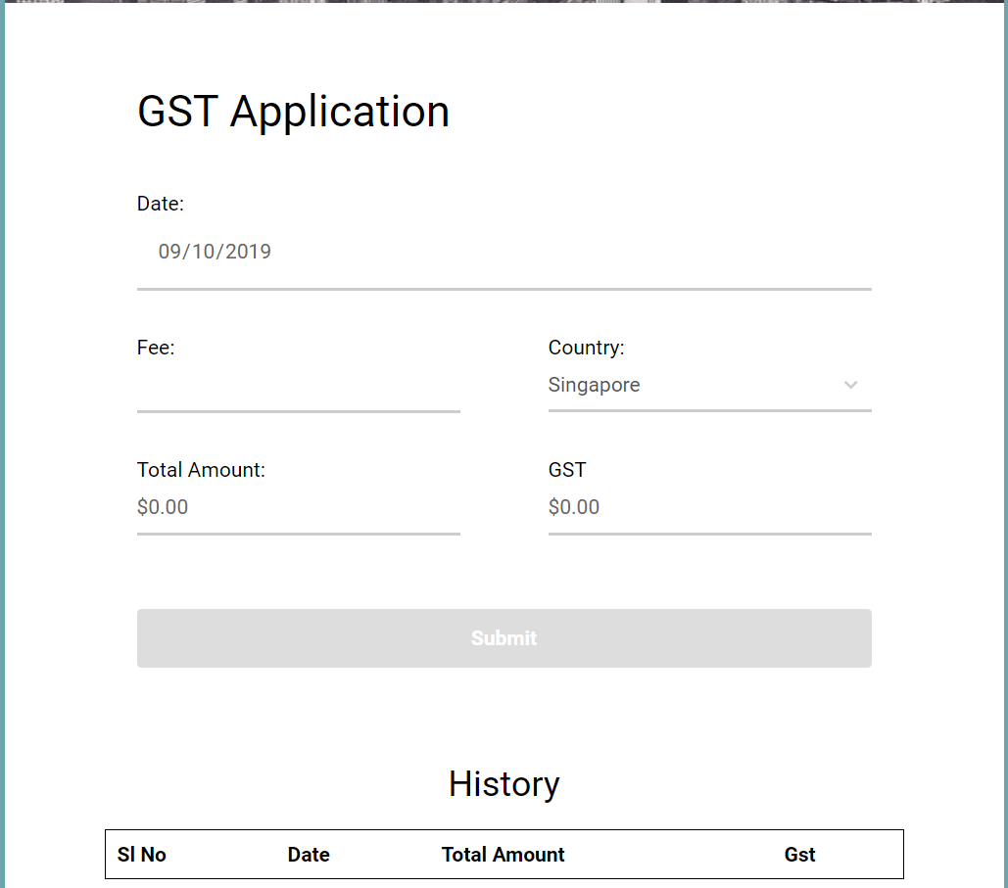

After filling the fee field, submit button is enabled with different color.

